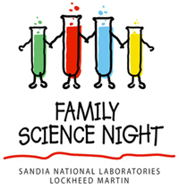
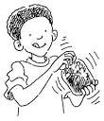
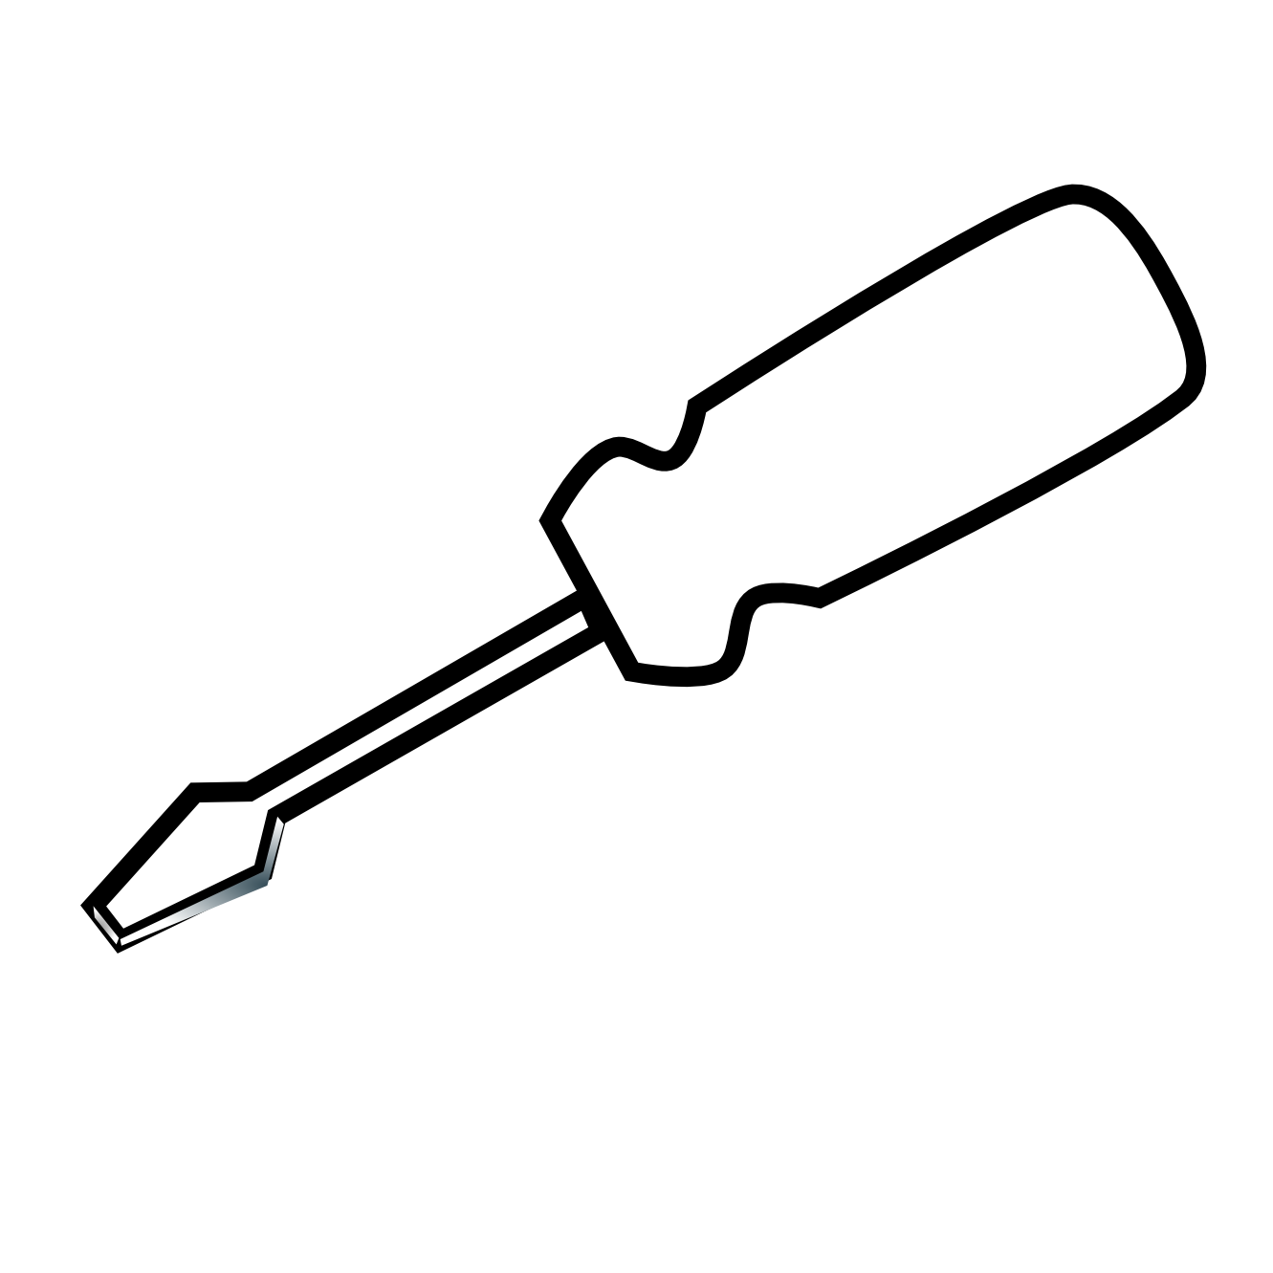

Science and Engineering

Family Nights

Save the Dates

At Science Night you can view science projects and inventions created by students. The winners of the Invention Conventions are announced at this time.

There will be hands-on stations where students of all ages can get messy with fun science and engineering projects.
  - Science night and
  - Invention Convention
  - 6-8pm Friday, feburary 27th
Come join us as explore how technology works
while we take apart old household appliances.
Bring your own object to take apart (toaster, windup toy, keyboard, phone, remote control etc.) or use a donated item.
This is also a great time to learn more about our
Annual Invention Convention!
Pizza will be served at 5pm.

Take apart night

5-7pm on Friday, january 9th
Questions?
Email, Ms. Imhoff at cimhoff@ashfordct.org or Mrs. Burnham at gburnham@ashfordct.org
(860) 429- 6419

