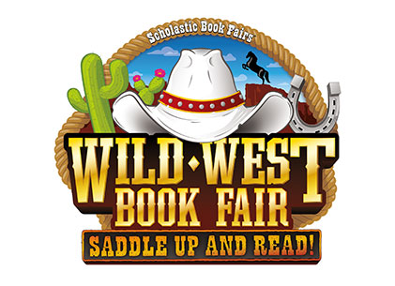
ASHFORD SCHOOL TO HOST
SCHOLASTIC BOOK FAIR EVENT
MONDAY, NOVEMBER 20TH AND TUESDAY NOVEMBER 21ST

What:
Ashford School will host a "Wild West" themed Scholastic Book Fair. Funds raised will help purchase books for; student birthday books, the Summer Reading Program and classroom libraries. Families, faculty, and the community are invited to attend this fun event that helps inspire children to become lifelong readers.

When:
The book fair will be open: Monday, November 20th and Tuesday, November 21st, from 8am to 7pm.

Where:
Ashford School Library, located at 440 Westford Road, Ashford, CT.

More:
The Book Fair offers specially priced books and educational products, including popular series, award-winning titles, new releases, adult bestsellers, and other great reads from dozens of publishers.

Volunteers Needed:
Please call or text: Lisa Hassett at (860) 933-7273. EVERY VOLUNTEER WILL EARN A FREE BOOK!

PLEASE NOTE: In "The Ashford Citizen" our book fair was advertised as a "luau" theme. That is incorrect. The theme is "Wild West."

