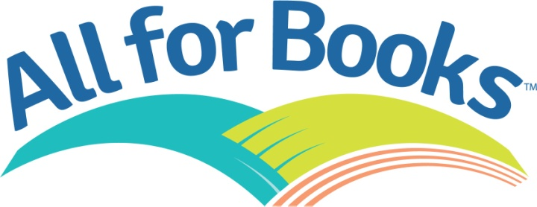
Dear Families:
Get ready to celebrate the love of reading with our upcoming Scholastic Book Fair! We will have many fun reading activities and events planned for your child at the Fair. We hope you can join us! Visit the Book Fair with your student(s) between 8am-7pm on Monday, November 20th and/or Tuesday, November 21st to join in the fun!
This year, one of our Book Fair goals is to ensure that as many children as possible have access to and receive books. One of the ways we can do that is through the All for Books program. With your help, donations will purchase books for; birthday books, books for the wonderful teacher's at Ashford School and students that may not be able to afford books.
Not only do your donations help Ashford School, but Scholastic Book Fairs® will match monetary donations of up to $1 million in books from The Scholastic Possible Fund. This fund distributes books to children in need through organizations such as Kids In Need Foundation, Reader to Reader, Inc., and the National Center for Families Learning.
Starting Wednesday, November 15th until Wednesday, November 22nd please consider donating $1 or loose change to the All For Books program. For every dollar your student donates, he/she will earn a "deputy badge" with their name on it to be displayed on the windows near the library. The GRADE (example: ALL of kindergarten, not just one classroom OR ALL of 7th grade, not just one classroom) that earns the most "deputy badges" by the end of the Book Fair, will win a spectacular prize!
Please send your money to school in an envelope labeled:
1. All for Books
2. Student Name
3. GRADE

The winning grade will be announced on the Monday AFTER Thanksgiving.

On behalf of the students and teachers of our school, THANK YOU!

Sincerely,
Nicole Fusco
CO-Chairperson for the Book Fair
Ashford School PTO

